**Lab 2**

**Author**

by Paul Charles

**Objective**

Learn HTML, css, bootstrap, Angular JS, AJAX, REST Technologies and JS. The main projects are to create a login, register, and a news page using the BBC source code. The second project is to create a tic-tac-toe game using Angular JS.

**Features**

* Login Page
* Register Page
* News (Home) Page
* Tic Tac Toe Game

**Configuration**

* HTML
* JavaScript
* CSS
* BootStrap
* Angular JS
* Jquery
* RESTful Services

**Demo (Input/Output)**

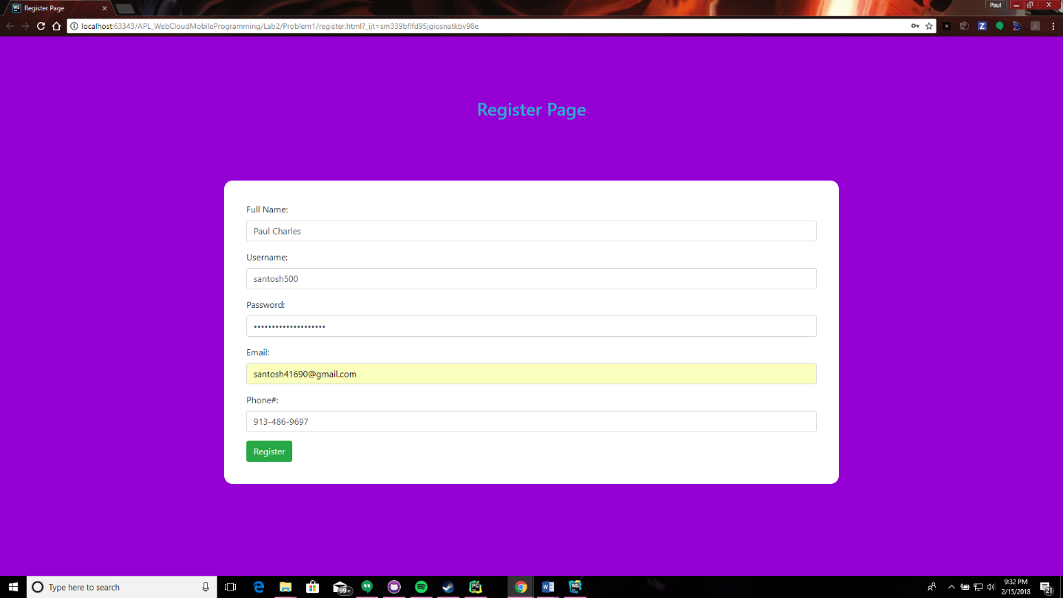

**Registration Page** This is the filled registration page. It goes to the next page.

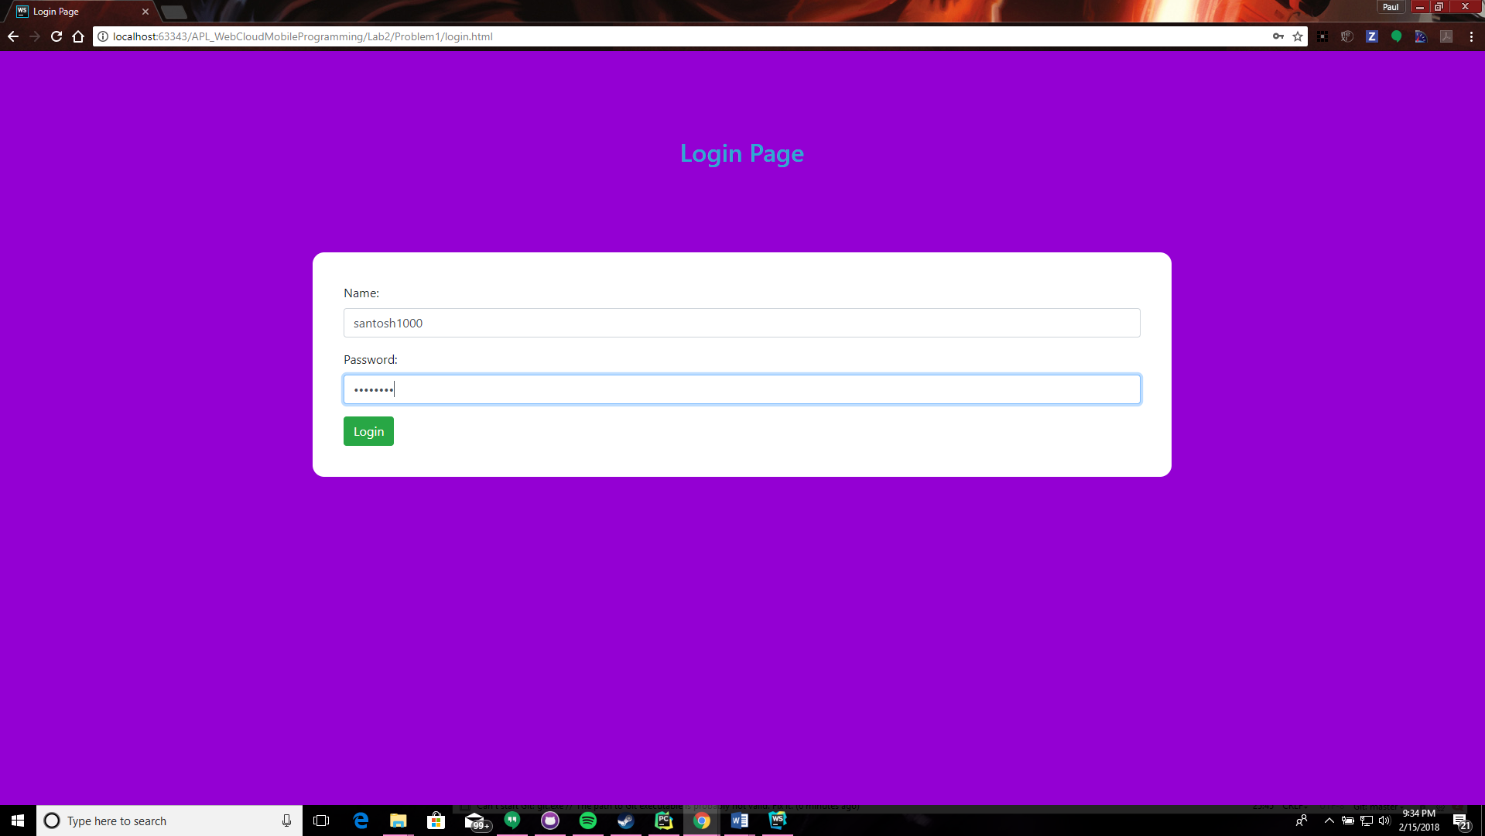

**Login Page** Can be utilized using username: santosh1000 and password: password

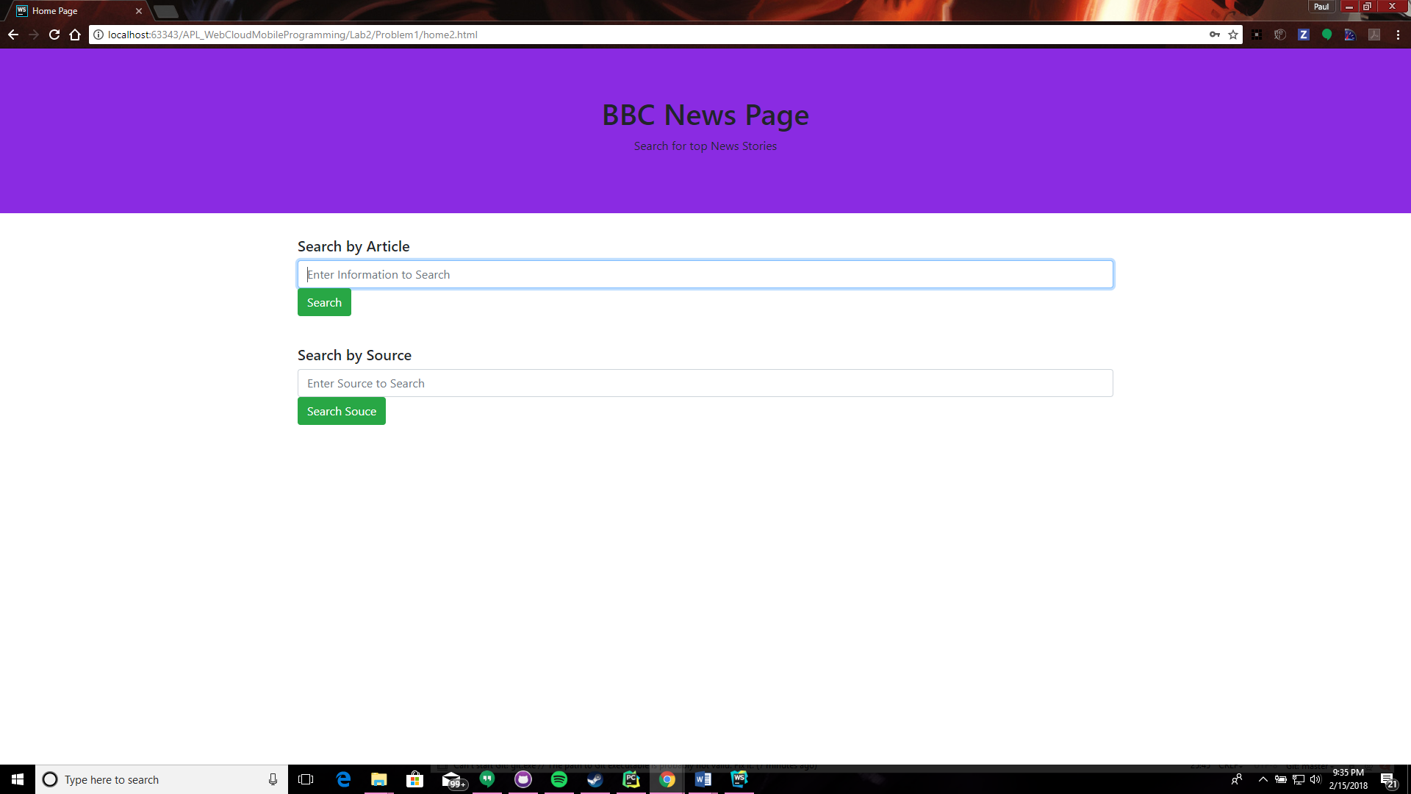

**News Page (blank)** This is a blank News Page

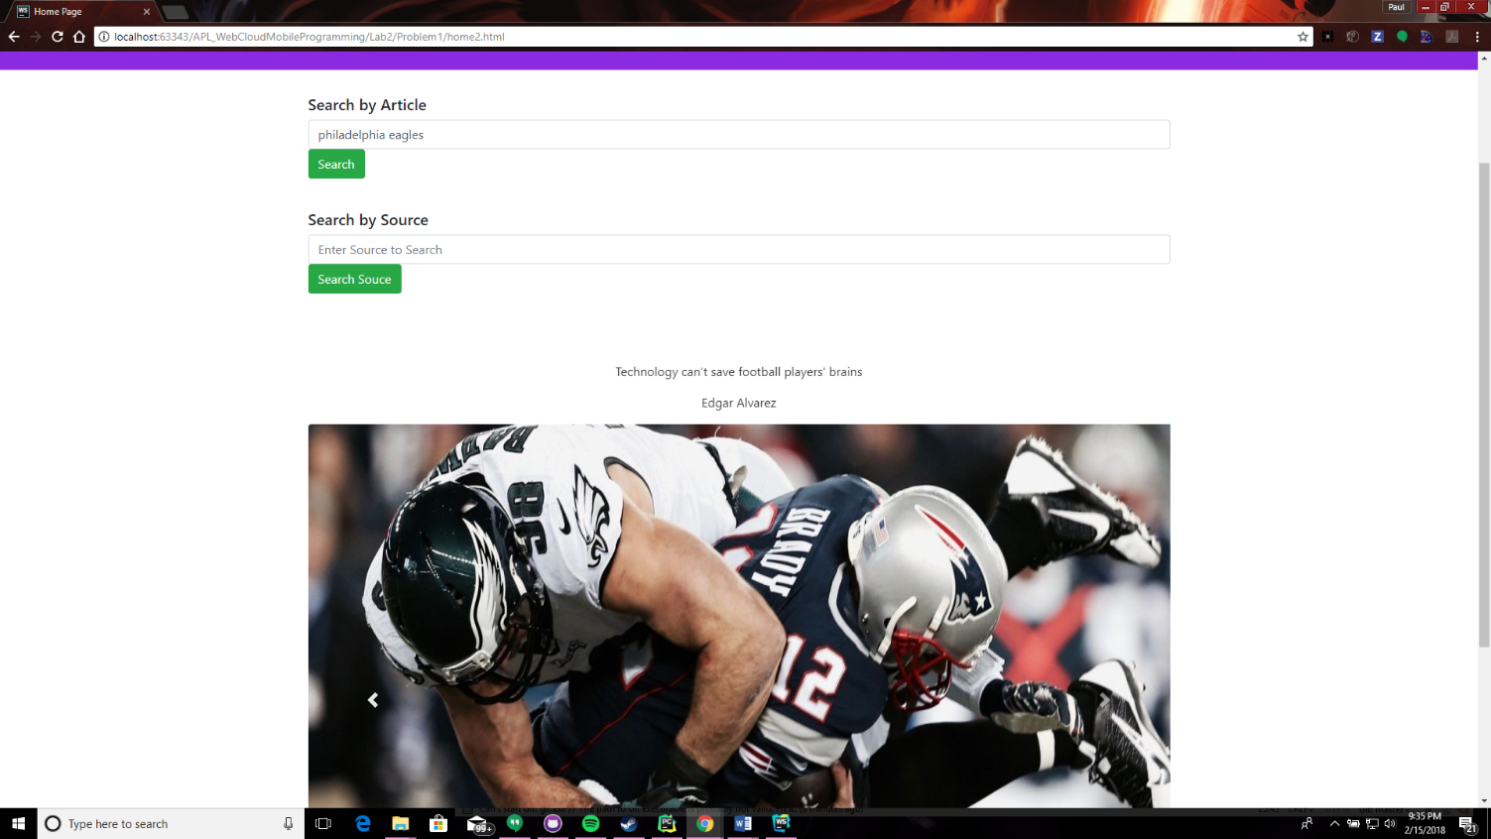

**News Page: Output** This is the output of the News page for the search "philadelphia eagles".

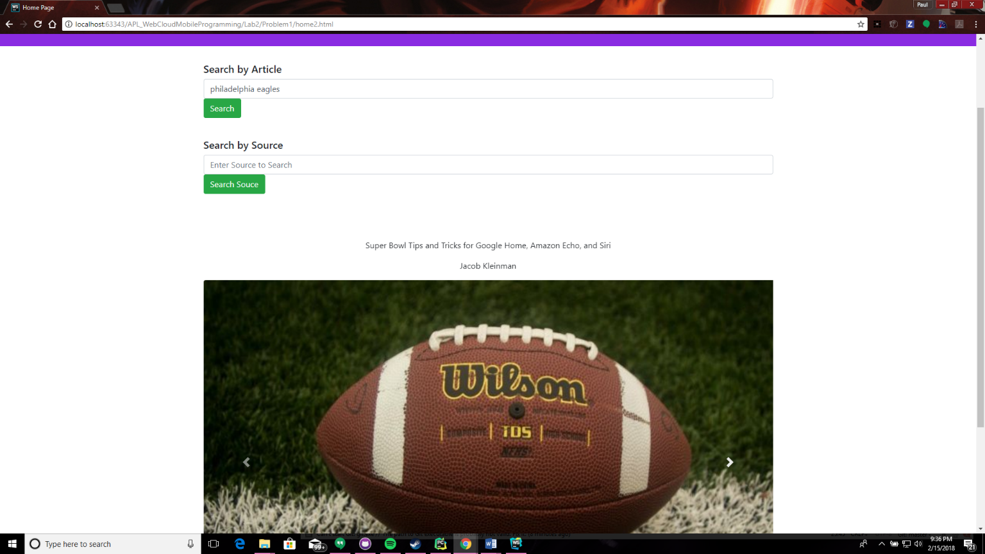

**News Page: Output 2** This is the second output of the News page for the search "philadelphia eagles".

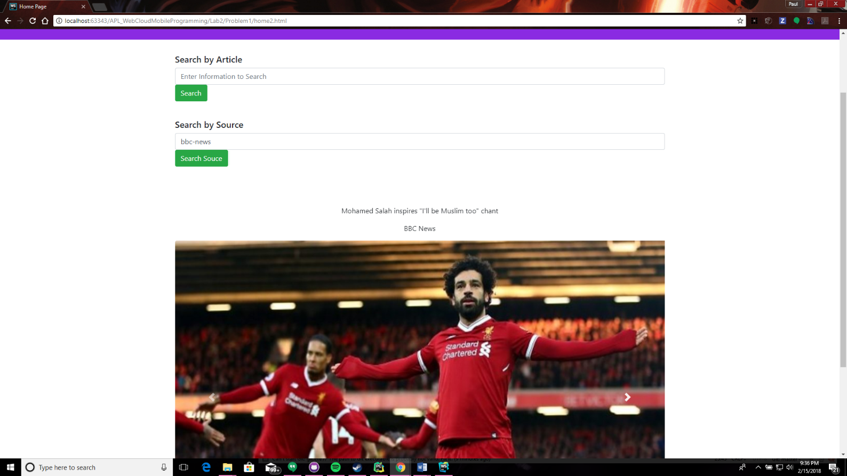

**News Page: Source search** This is the search result for source: BBC news

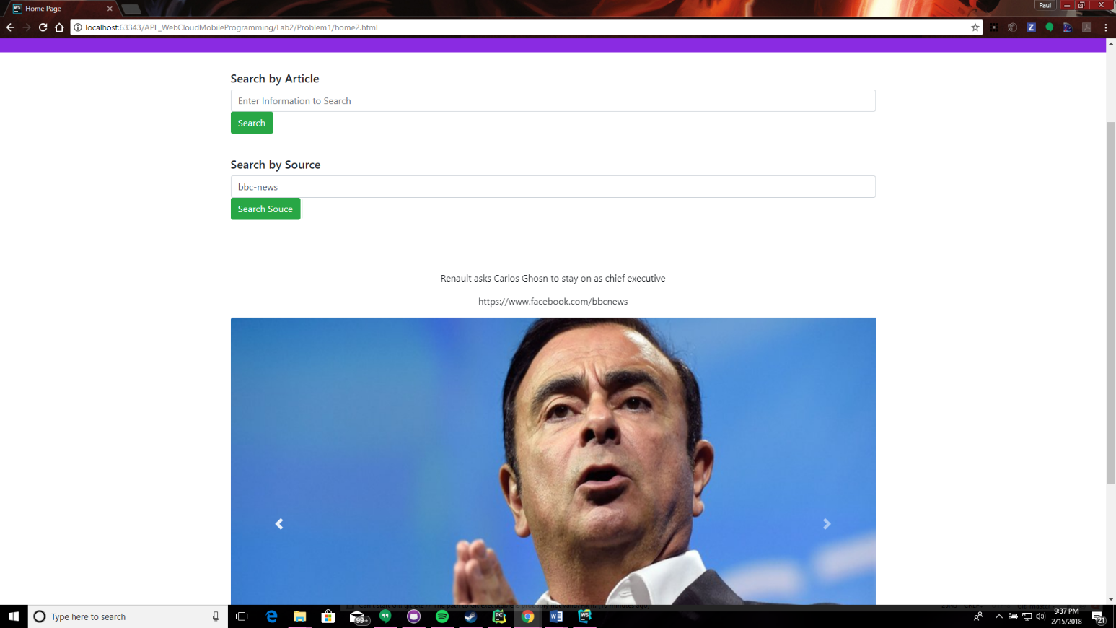

**News Page: Source search 2** This is the second search result for source: BBC news

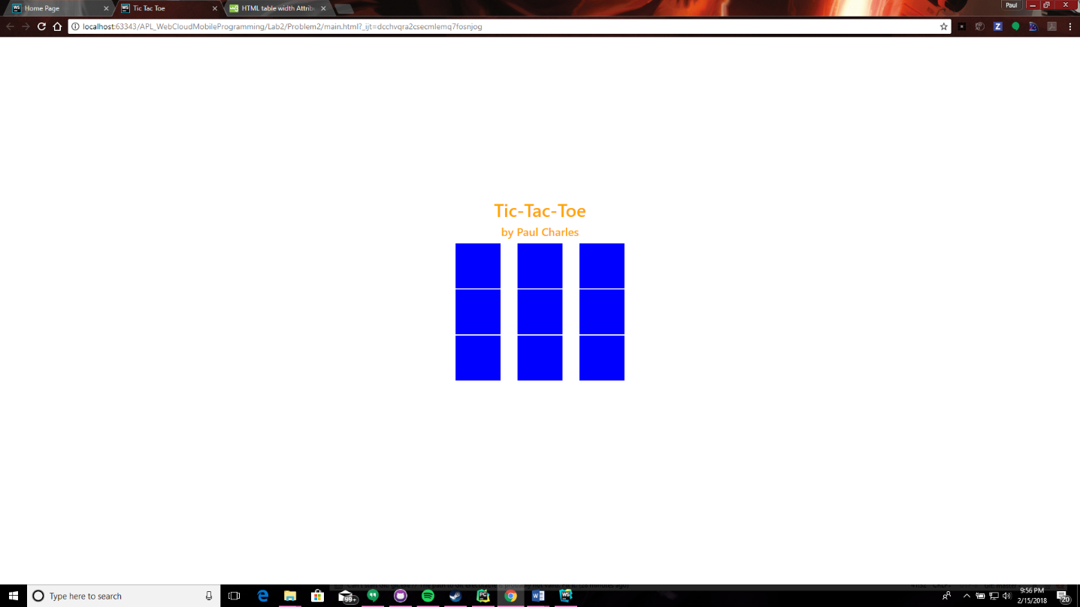

**Tic-Tac-Toe: Board** This is the empty board of the game

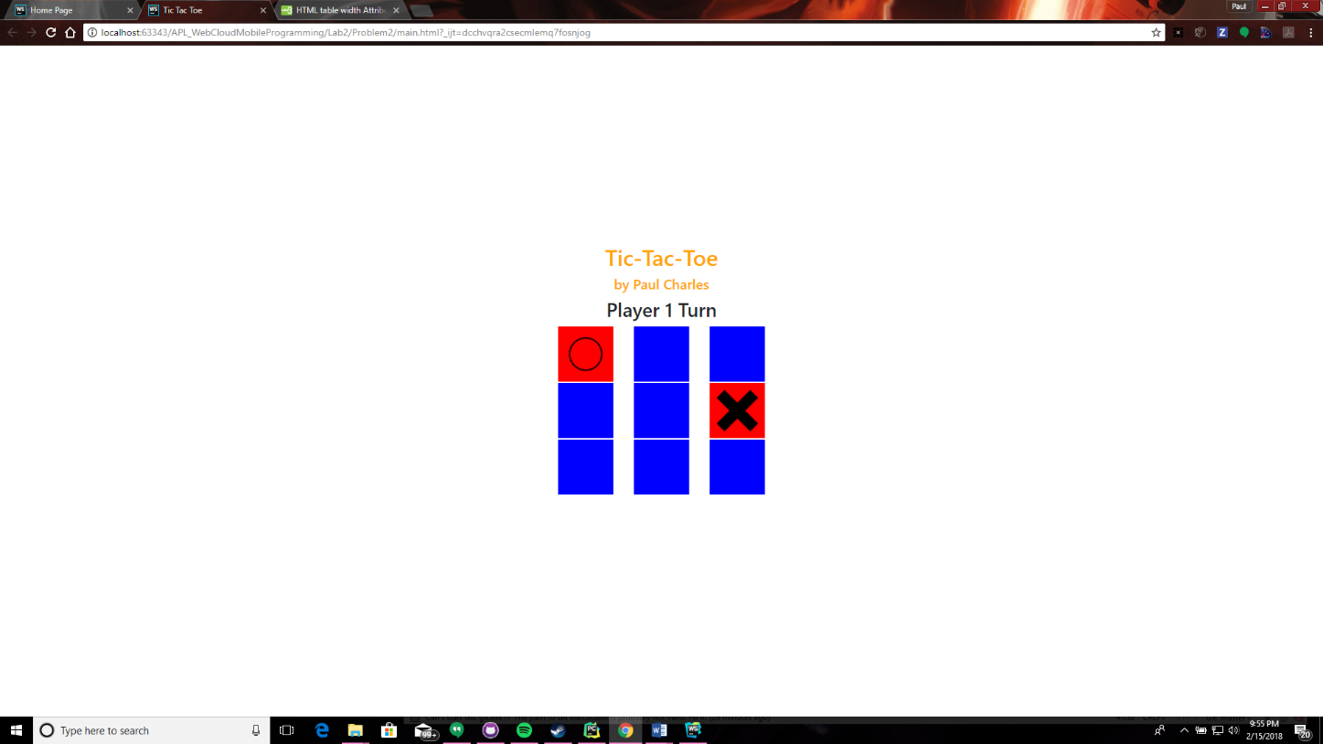

**Tic-Tac-Toe: Play** This is the users playing the game.

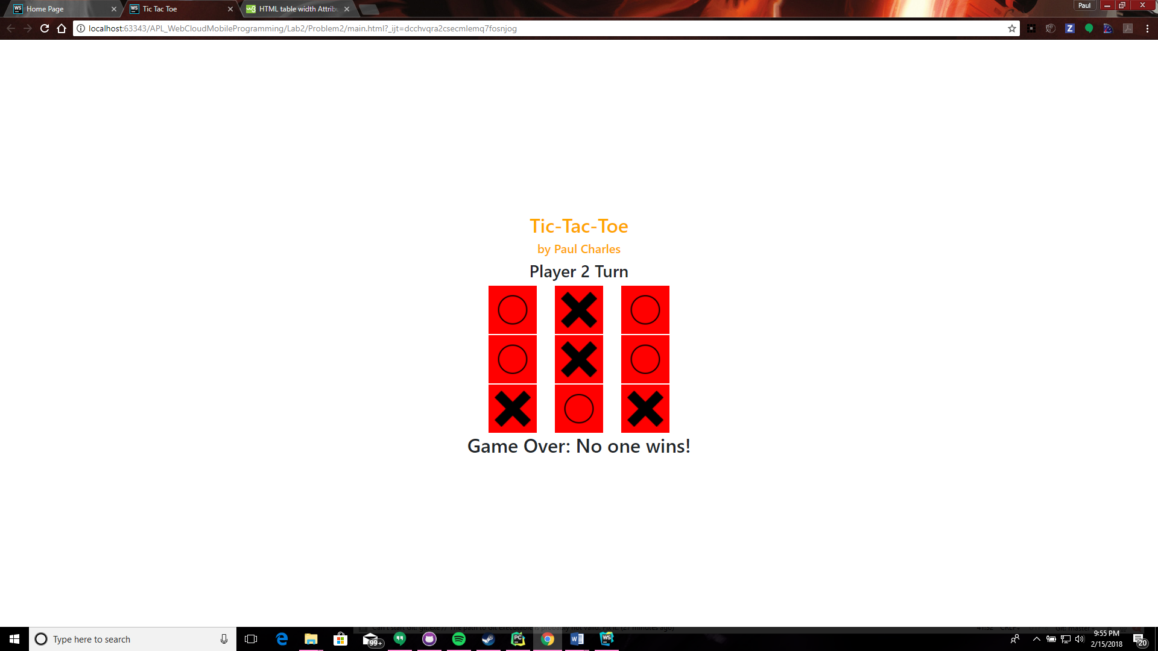

**Tic-Tac-Toe: Tie** This is the game when it is a tie.

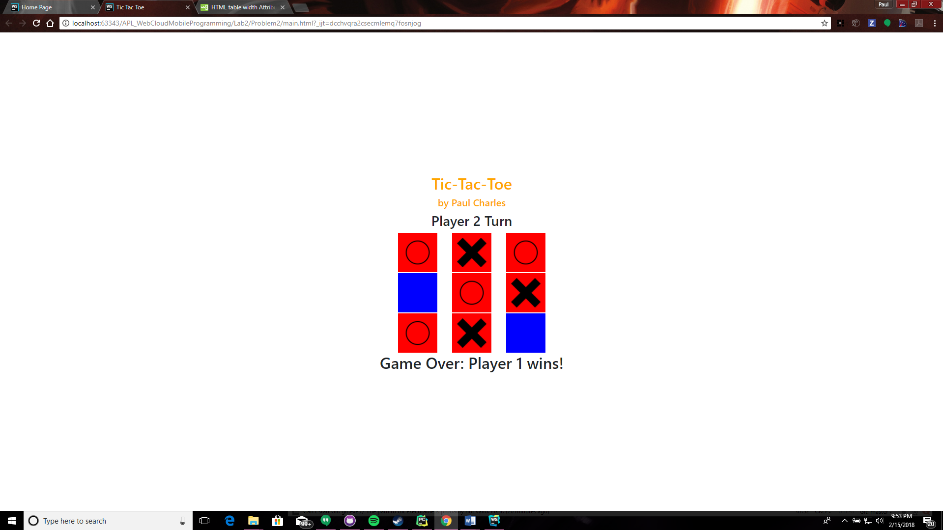

**Tic-Tac-Toe: Win** This is a user winning the game.

**Implementation**

$("#regBtn").click(function(){ var username = $('#uname').val() var password = $('#pass').val(); var name = $('#name').val() var email = $('#email').val(); var number = $('#number').val(); if(username=="" || password=="" || name=="" || email=="" || number=="") { $("#warning").html('

**Please fill in all fields**

'); console.log("failure"); } else { console.log("success"); window.location='login.html' } });

**Example of Angular JS** This code snippet shows that JS that takes the input values for registration.

**Deployment**

The code was executed in Webstorm to create the code. The code was then added to Github and committed. The code was then pushed to my Github account. The code was in the Source folder, and the images and documentation was in the Documentation folder.

**Limitations**

This was good experience, it could have helped to use more angular and to use different folders and pages than using it as one.

**References**

**W3Schools:**I referred to W3 Schools for help and references to complete my lab. This included carousel for bootstrap, html and js elements, as well as AngularJS features. General link is <https://www.w3schools.com/>

**BBC News API:**I referred to BBC API to help finish the lab. This also included documentation. General link is <https://newsapi.org/s/bbc-news-api>